Experiment 14

(By Aman Tyagi)

Aim: Working with Metadata, Log File using Docker

1) Adding single label

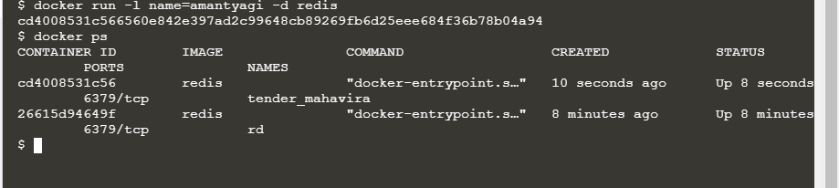

2) Inspecting

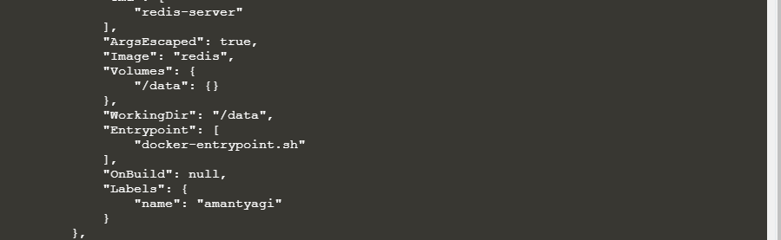

3) Adding multiple labels

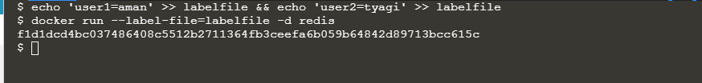

4) Inspecting

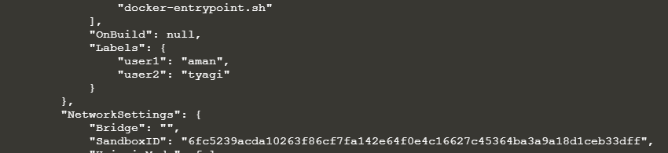

5) Filtering the search

